**Lab# 1: Introduction to Java**

**Output:**

1. **Write a program to display “Hello World” to the user.**

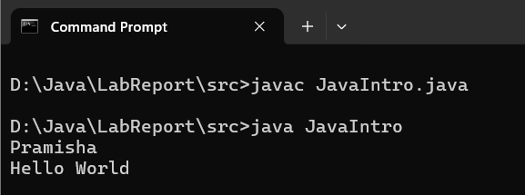

**Lab# 2: Tokens, Expressions and Control Structures**

**Output:**

1. **Write a program to find the smallest number between 3 entered number using if else statement.**

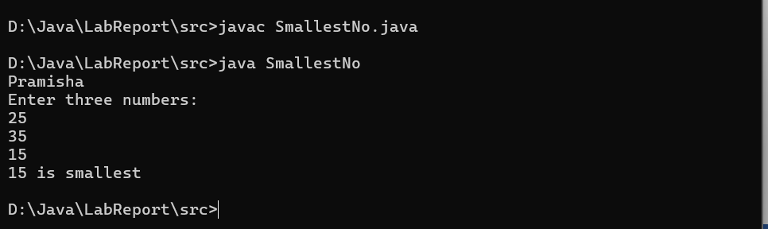

1. **Write a program to find grade of a student using switch Case.**

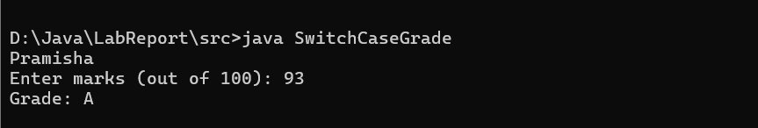

1. **Write a program to find the Fibonacci series.**

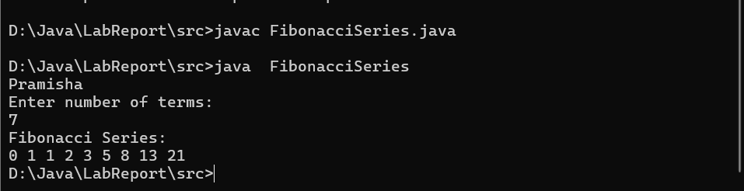

1. **Write a program that demonstrates the use of break statement and continue statement.**

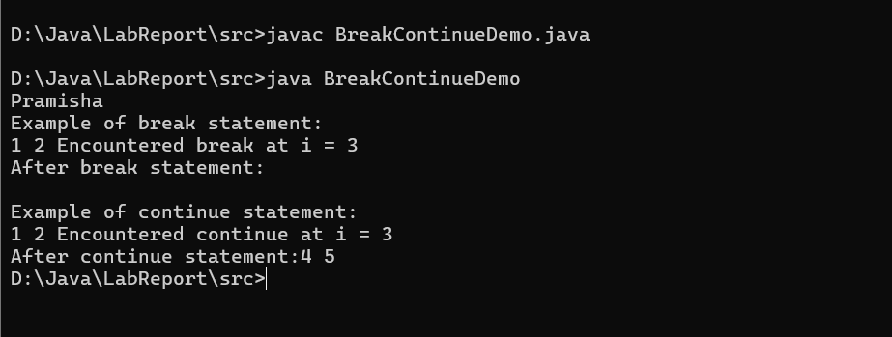

1. **Write a program to take two numbers as input and then show the results of addition, subtraction, multiplication, division, and modulus operations using these numbers.**

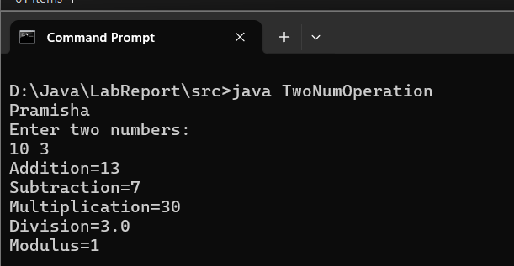

1. **Write a program compares two integers using each of the relational operators and displays the results.**

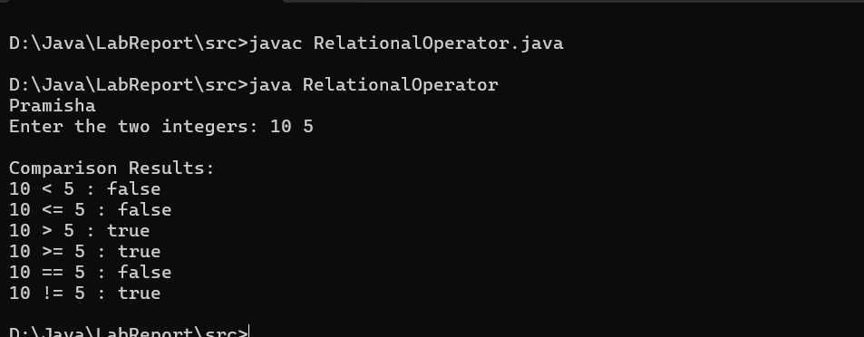

**10) Write a program to find the smallest of three number using conditional operator.**

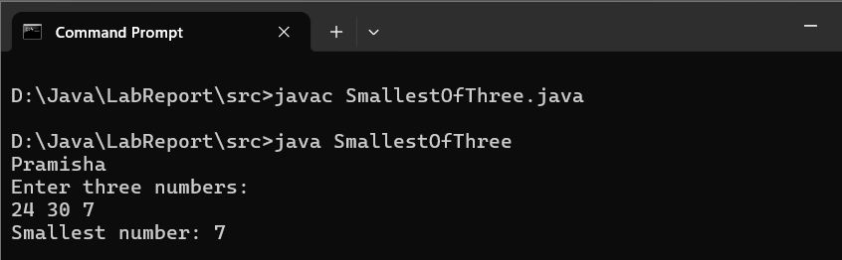

1. **Write a program that demonstrates the use of all logical operators (&&, ||, and !). This program will evaluate several logical expressions and print the results.**

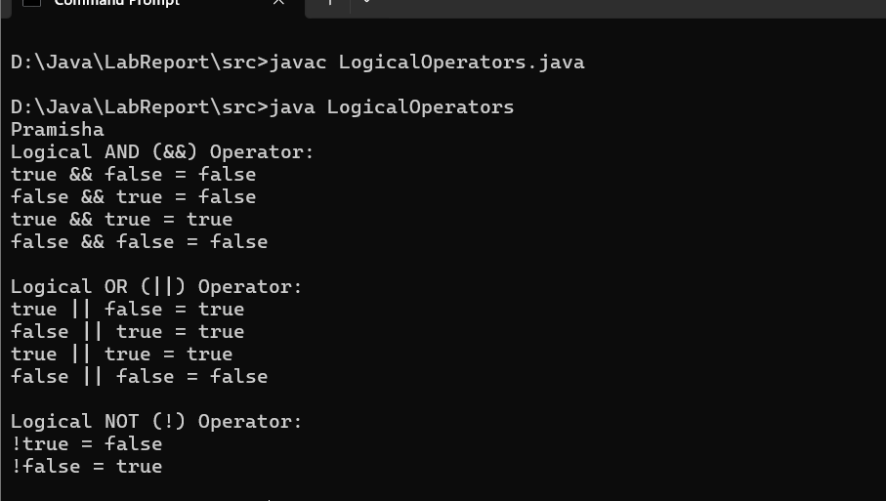

1. **Write a program compares two integers using each of the relational operators and displays the results.**

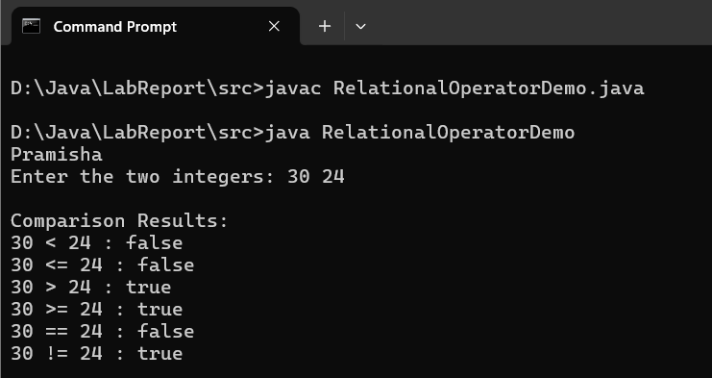

**11) Write a program to swap two numbers without using third variable.**

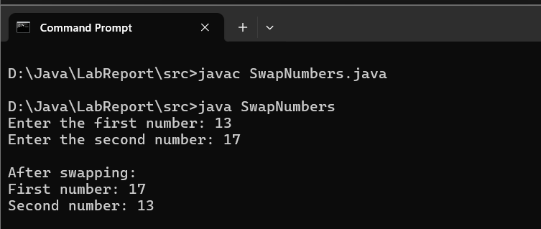

1. **Write a program to perform different bitwise operations on two integers.**

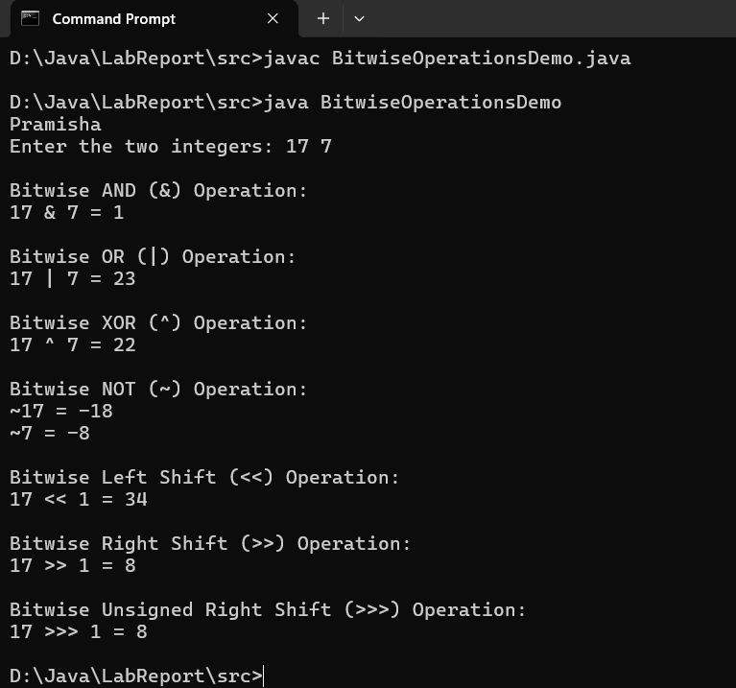

**Lab# 3: Object Oriented Programming Concepts**

**Outputs:**

1. **Write a program to demonstrate concept of class and object.**

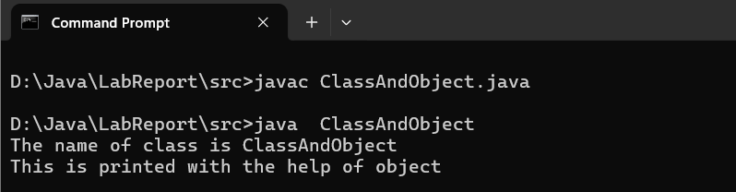

1. **Write a program to demonstrate concept of calling methods**

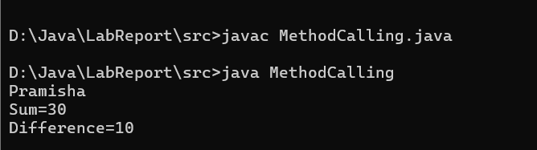

1. **Write a program to demonstrate concept of ‘this’ keyword.**

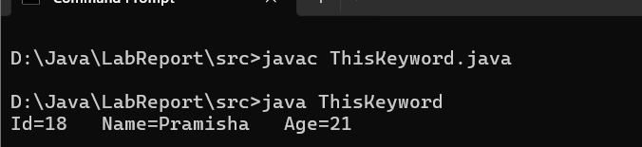

**4. Write a program to demonstrate concept of parameterize constructors.**

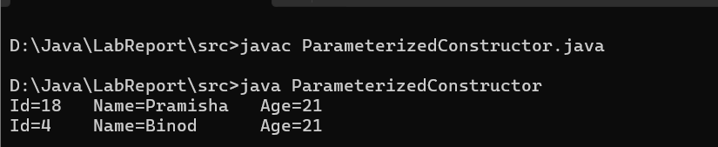

1. **Write a program to demonstrate concept of passing by value.**

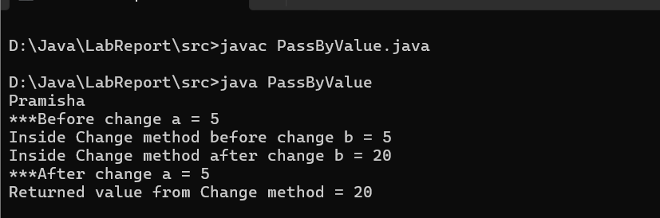

1. **Write a program to demonstrate concept of method overloading.**

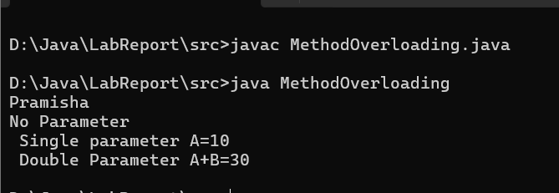

1. **Write a program to demonstrate concept of nested inner classes.**

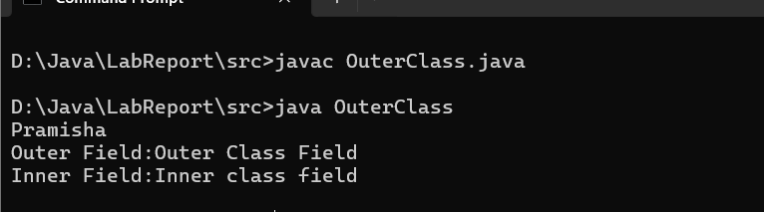

1. **Recursive program to find the factorial of an integer.**

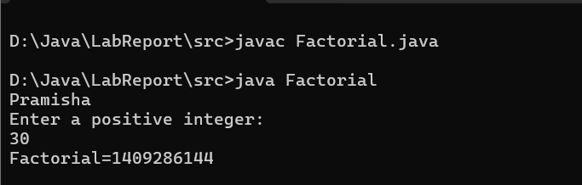

**Lab# 4: Inheritance & Packaging**

**Outputs:**

1. **Write a program to demonstrate concept of abstract class.**

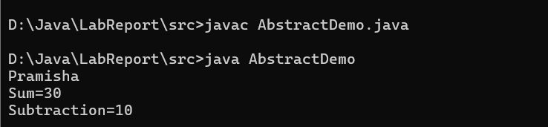

1. **Write a program to demonstrate concept of super keyword.**

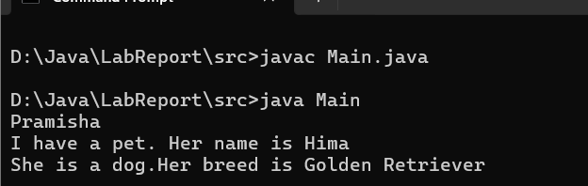

1. **Write a program to demonstrate concept of overriding methods.**

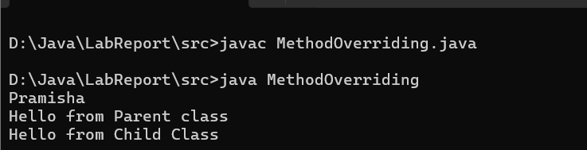

1. **Write a program to demonstrate concept of interface.**

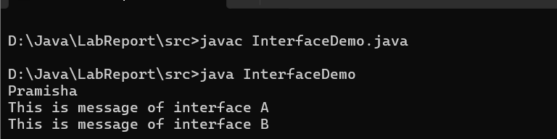

1. **Write a program to demonstrate concept of final class.**

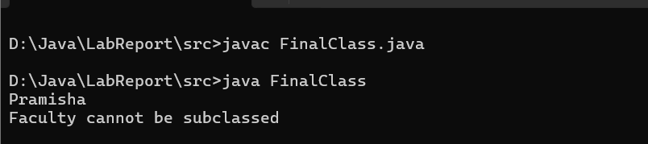

**6. Write a program to demonstrate concept of package.**

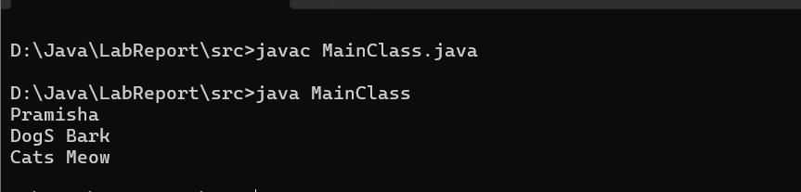

**Lab# 5: Handling Error/Exception**

**Outputs:**

**1. Write a program to demonstrate concept of exception.**

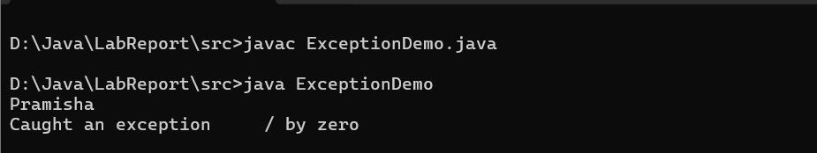

**2. Write a program to demonstrate concept of user defined exception.**

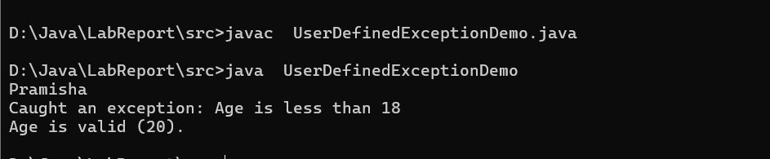

1. **Write a program to demonstrate concept of throw and throws.**

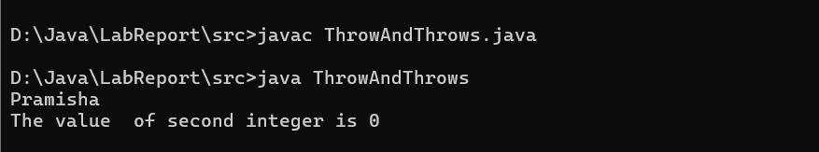

**Lab# 6: Handling Strings**

**Outputs:**

**1. Write a program to demonstrate concept of string buffer.**

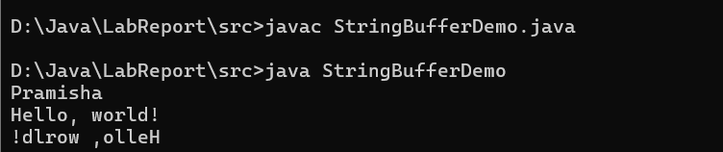

**2. Write a program to find the string is palindrome or not.**

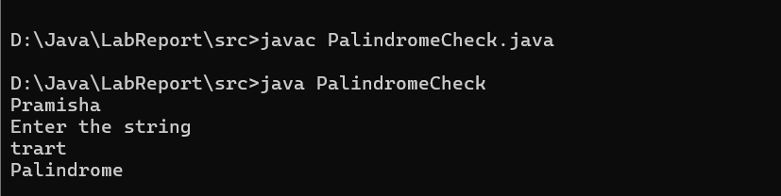

**Lab# 7: Threads**

**Outputs:**

**1. Write a program to demonstrate concept of threads.**

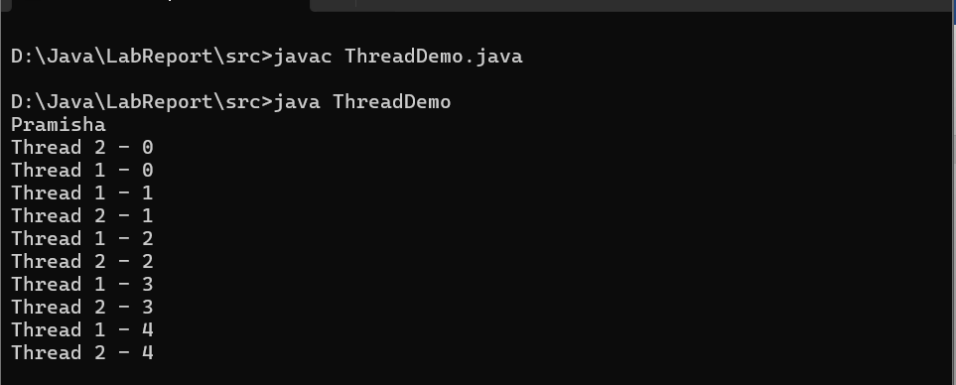

**3. Write a program to demonstrate concept of synchronization.**

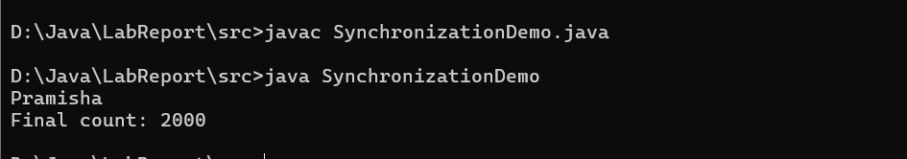

**2. Write a program to demonstrate concept of runnable interface.**

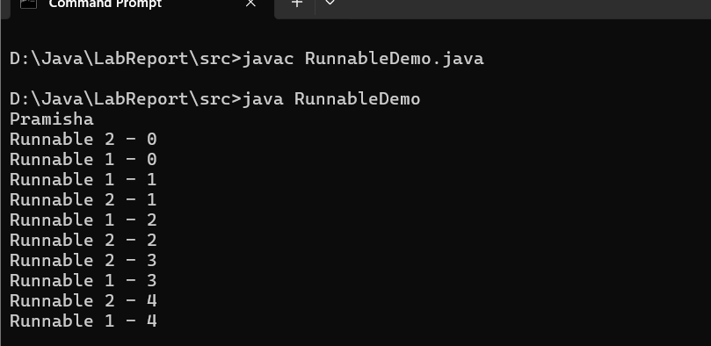

1. **Write a program to demonstrate concept of deadlock.**

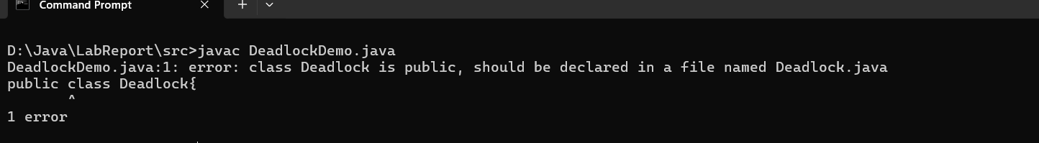

**2. Write a program to demonstrate concept of Serialization.**

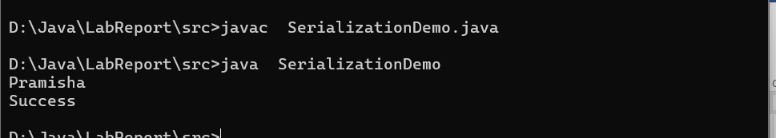

1. **Write a program to demonstrate concept of Deserialization.**

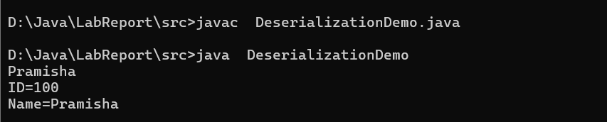

**4. Write a program to demonstrate concept of Hashset.**

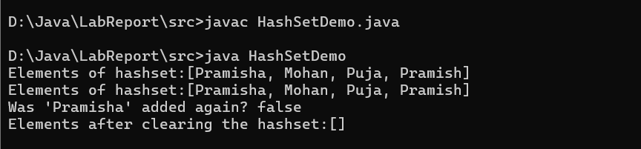

**Lab# 8: I/O and Streams**

**Outputs:**

**1. Write a program to demonstrate concept of reading and writing files.**

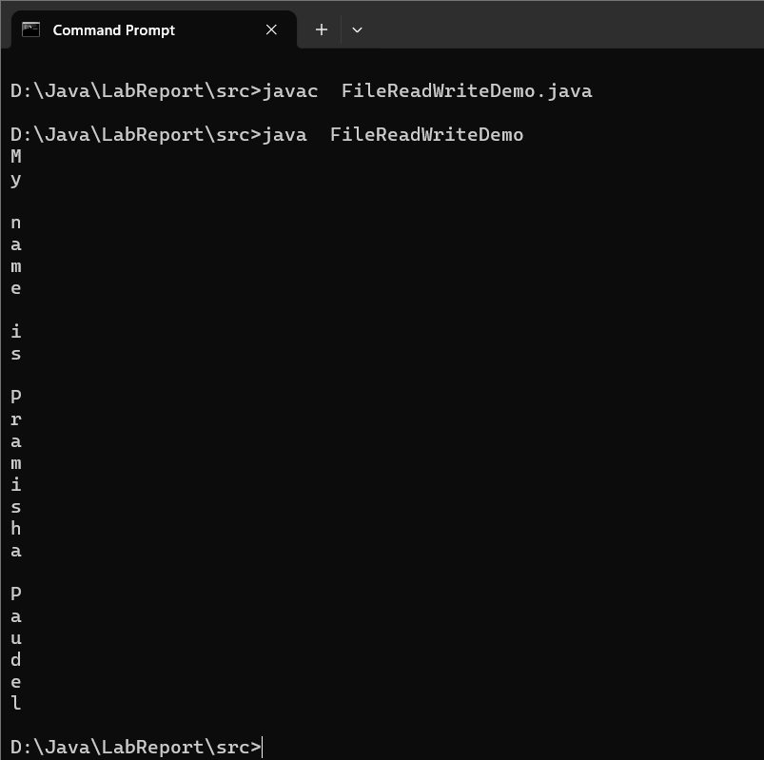

**2. Write a program to demonstrate concept of Vector.**

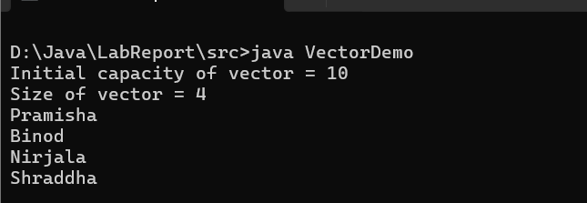

**Lab# 9: Understanding Core Packages**

**Outputs:**

**1. Write a program to demonstrate concept of wrapper class.**

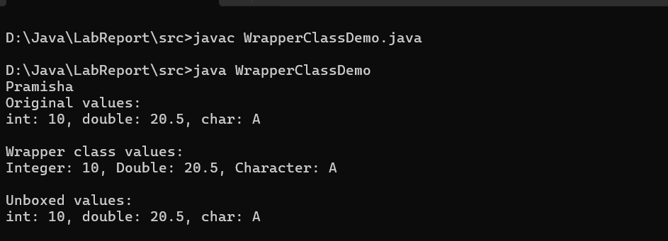

**3. Write a program to demonstrate concept of Dictionary.**

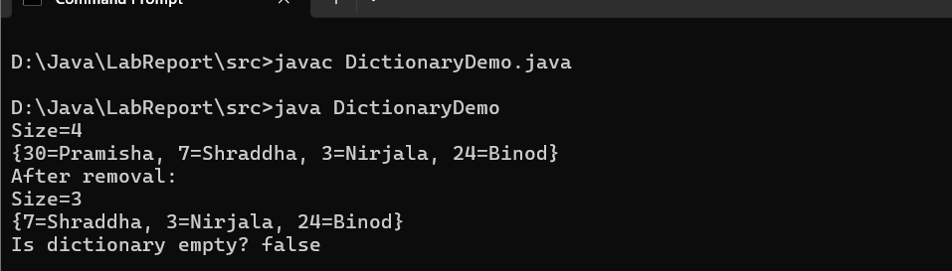

**4. Write a program to demonstrate concept of Hashtable.**

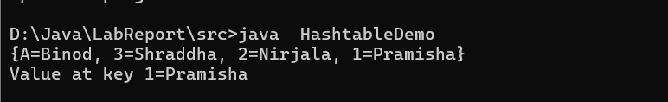

1. **Write a program to demonstrate concept of Random Number Generation.**

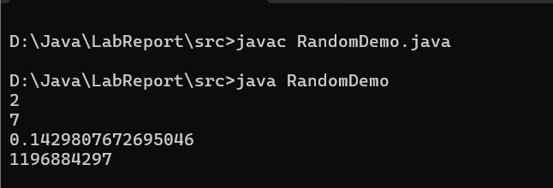

**Lab# 10: Holding Collection of Data**

**Outputs:**

**1. Write a program to demonstrate concept of ArrayList.**

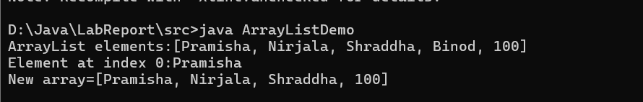

**2. Write a program to demonstrate concept of Linked.**

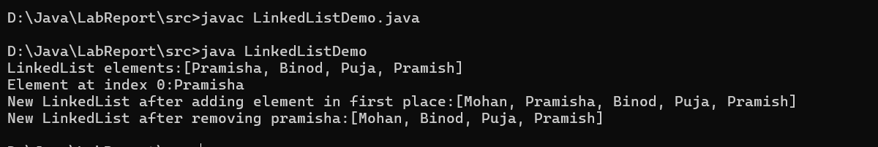

**3. Write a program to demonstrate concept of List interface.**

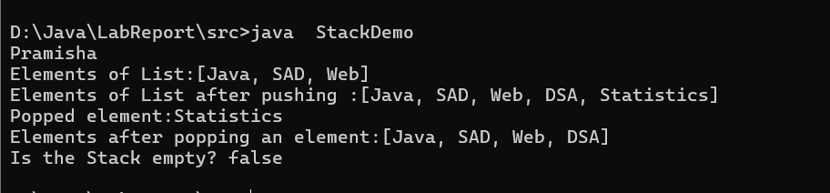

**5. Write a program to demonstrate concept of Comparator.**

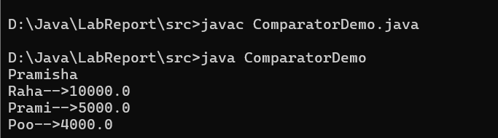

**Lab# 11: Java Applications**

**Outputs:**

**1) Write a program to create Swing application that receive two numbers through a JTextFeilds and display the multiplication two numbers in a JTextField when the OK button is pressed and when exit button is pressed the program will terminate.**

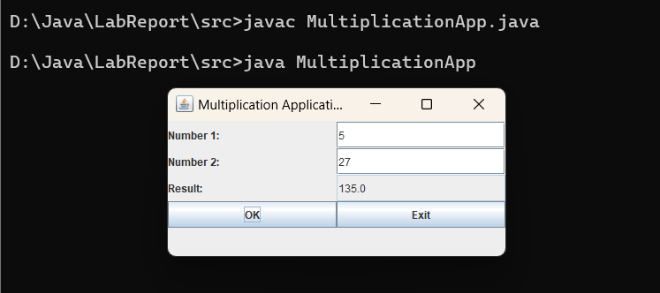

**2) Write a program to demonstrate concept of layout manager.**

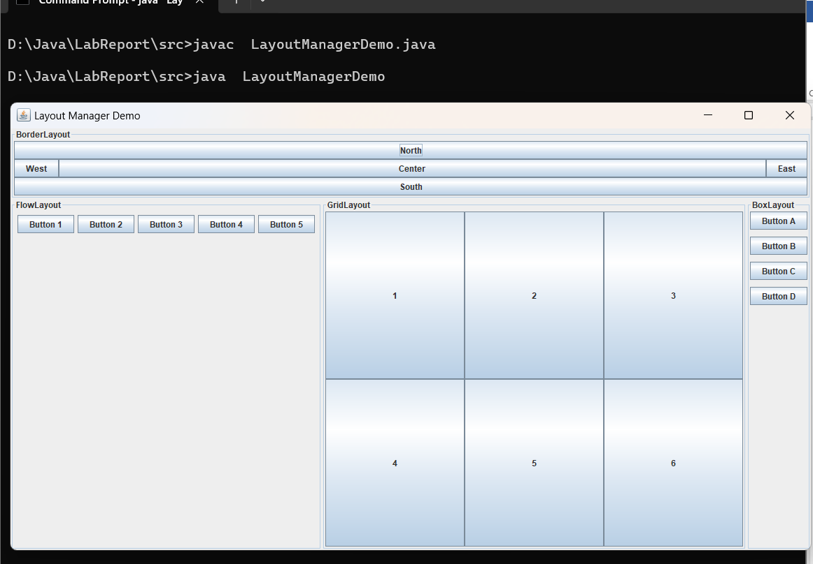

**3) Write a program to change background color of a frame using action event.**

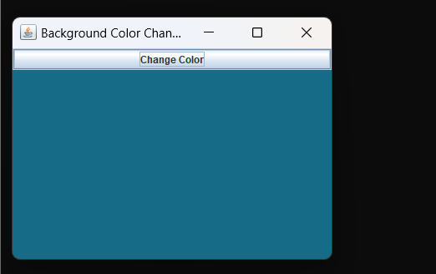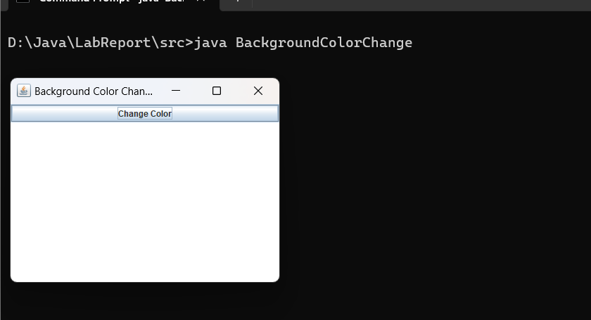

**4) Write a program to create a table using Jtable class and then add it to the Jframe container.**

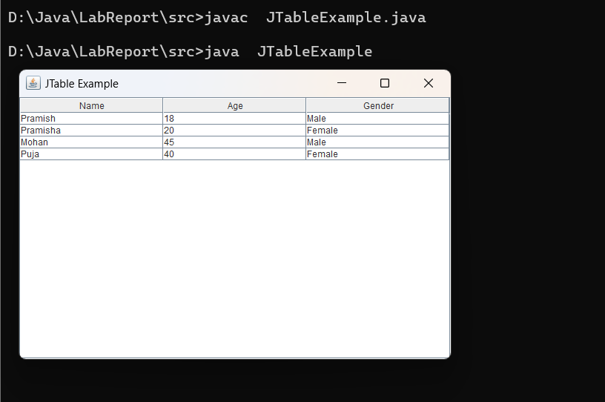

**Unit 12: Introduction to Java Applets**

**Outputs:**

1. **Write a program to demonstrate concept of lifecycle of applet.**

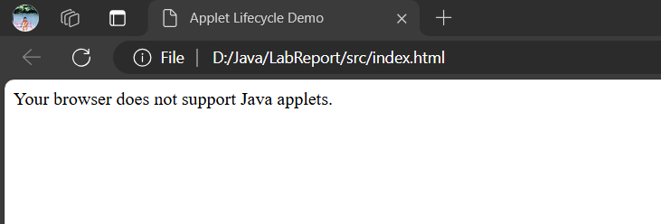

**Lab# 13: Database Programming using JDBC**

**Output:**

**1) Write a program to display student details from student table.**

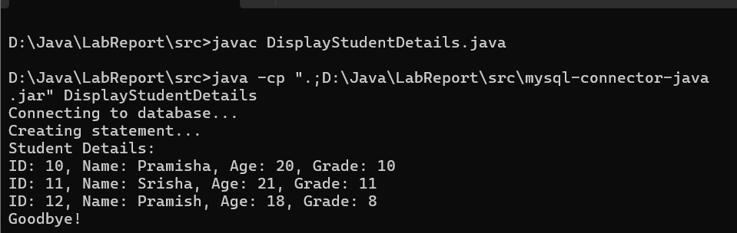

**Database:**

